3.31: Solving Eq. (3.30) for T in terms of R and 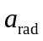,
a)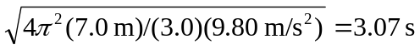. b) 1.68 s.

